6/12/2015

# Instructions for using WinAutomation for EFiling Complaints

These instructions are written for “Cathy”. Modify for use in your own environment

There are these parts to EFiling Complaints

* Cleaning out old files from the last run
* Scanning Signed Complaints to the Z: Drive, and Copying the Files
* Using the LTPROD Access application to make a **Helper Excel File**
* Step A - Renaming Signed Files
* Connect to EFile Express in the Internet Explorer Web Browser
* Step B – Efile the Named Complaints

# Cleaning out old files from the last run

* Use **Windows Explorer**. You can get to Windows Explorer from the “Windows Start Menu” you see when clicking the **Start Button** (shaped like the earth, with a Microsoft flag covering it) on the lower left of your Desktop

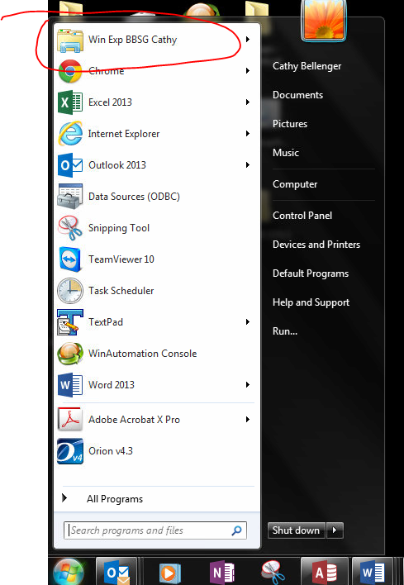

* Delete all the files in these directories
* F:\CATHY EFILE 2\SingleTargetFile
* F:\CATHY EFILE 2\Step 1 – Signed Complaints
* F:\CATHY EFILE 2\Step 1 Backup – Signed Complaints That Were Renamed
* F:\CATHY EFILE 2\Step 2 – Named Complaints
* F:\CATHY EFILE 2\Step 3 – Complaints That Were EFiled

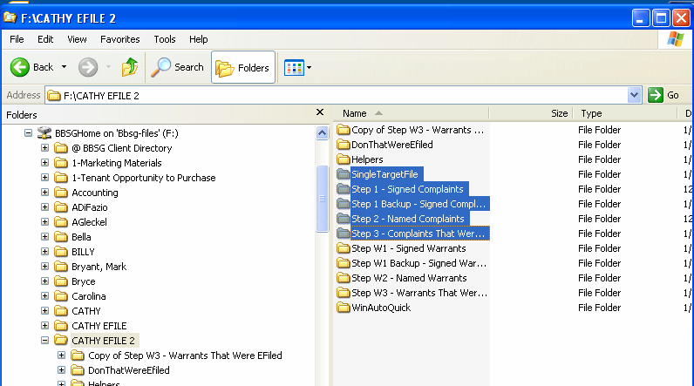

# Scanning Signed Complaints to the Z: Drive, and Copying the Files

* Scan each signed Complaint into. Z:\cathy
* Remember the date and time when you did the scan
* Go to Z:\cathy in Windows Explorer
* IF you don’t see the “Date Modified” column, click the icon way to the right of “New Folder”, and select “Detail”

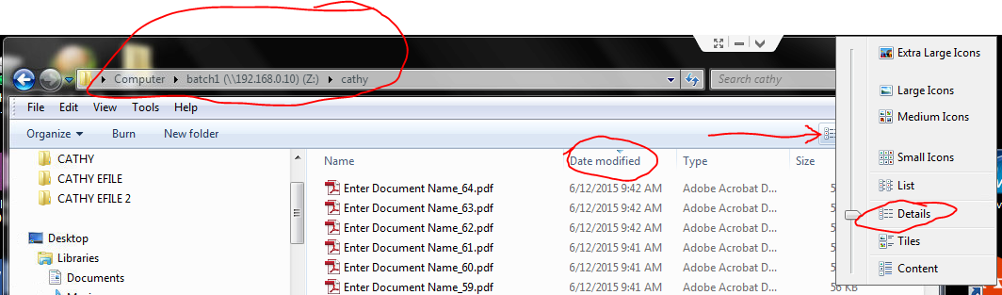

* Select the relevant files. You can look at Date Modified to see if you have the right files.
* EITHER use the mouse and shift key
* OR click on the first file, hold the shift key, and hit the down arrow until you get to the last file

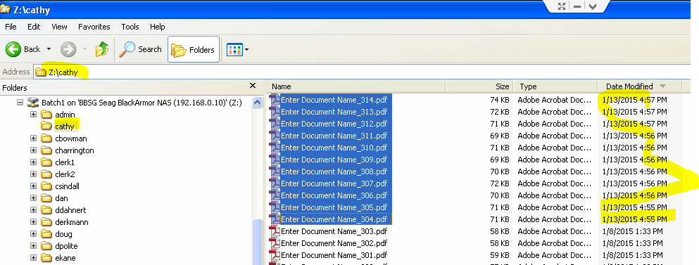

* Press ctrl-C to copy the files.
* Navigate to F:\CATHY EFILE 2\Step 1 – Signed Complaints
* Press ctrl-V to paste the files.
* Right-click on the F:\CATHY EFILE 2\Step 1 – Signed Complaints folder, select Properties, and note the number of files. For example, in the picture below, there are 271 complaints to EFile.

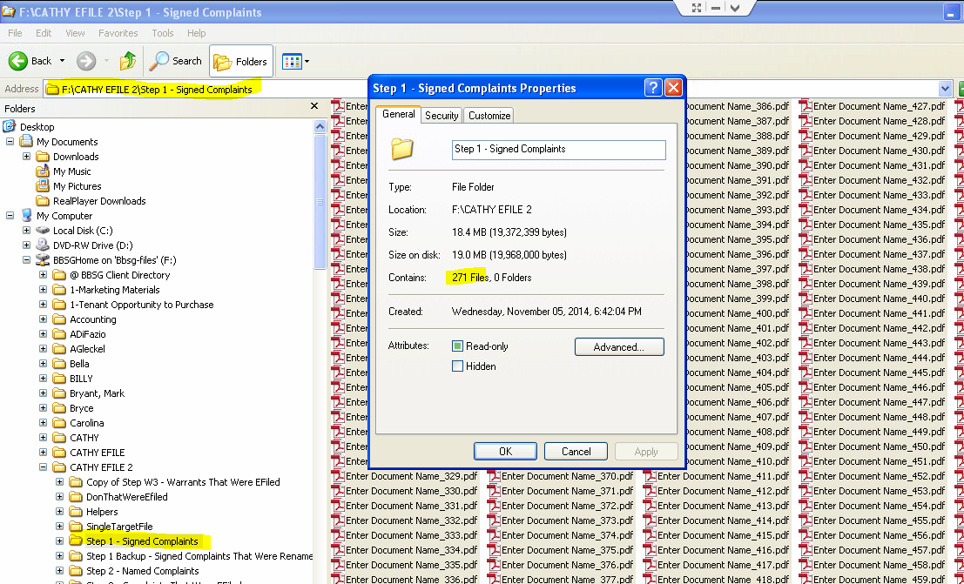

# Using the LTPROD Access application to make a Helper Excel File

* Go to the **LTPROD** Access application
* Calculate Absolutes for the correct Property
  + For example, select Villages at Morgan Metro
  + Leave the Date for First Transaction as it is
  + Click OK
* Click Invoices
* Highlight the invoice associated with the Complaints. This should be the most recent invoice. You can tell by comparing the date of the invoice to the date on the Complaint.
* Click Complaints
* Click the icon to go to the last complaint. The icon is the second to the right from the page number at the bottom of the Complaint Report window.
* Note the number of complaints (in the example, there are 277, so there are 6 complaints that were not signed).
* If you are “close enough”, close the Complaint screen, and click the **EFCompl** (EFile Complaint) button, on the far left bottom of the Invoices screen.

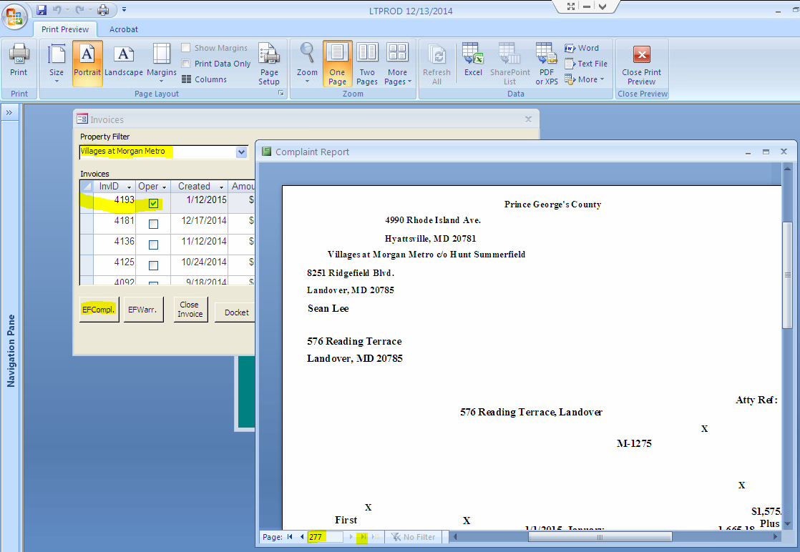

* Click OK to accept the default “CSV” file name.

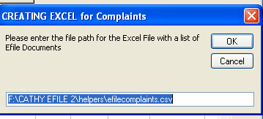

* Enter the complex name, properly capitalized.
* Click OK

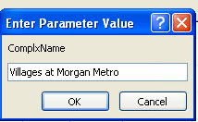

* Do the following checks. There should be the correct number of records in the generated csv file. You can see there are 277 in this example. Mainly, , if the Excel file is empty right here, you picked the wrong invoice.
* Notice the name and location of the file you have just created.

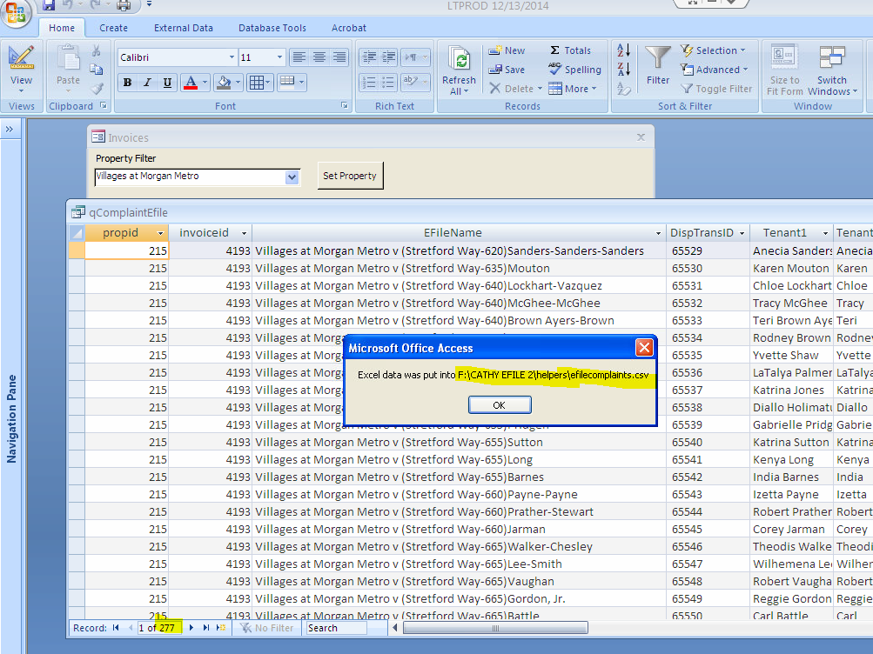

* Close the Access application; you don’t need it any more.
* In Windows explorer, go to F:\CATHY EFILE 2\Helpers.
* Find the .csv file you just created. Be sure you have the right file, based on date.
* RIGHT click on the file name
* Select Open. This brings up the file in Excel.

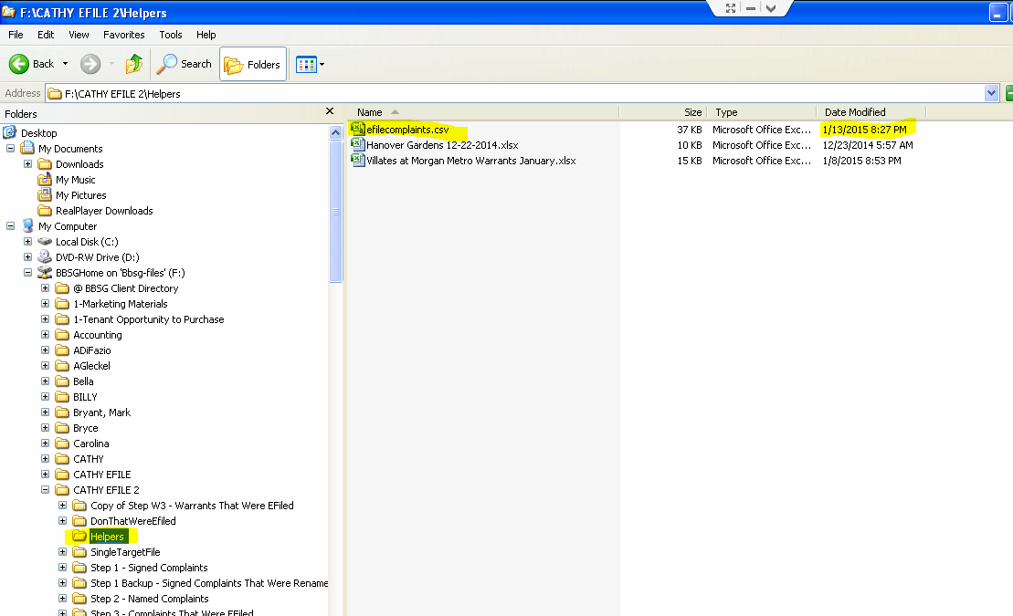

* Be sure you have the correct number of records in the spreadsheet, by scrolling to the bottom, and noting the row number.
* Click “Save As”
* Click the drop-down icon at the right of the “**Save as Type**” text box. It is below the File Name text box (see picture below).
* Select “**xlsx file**”. This is the topmost item in the list of options for Type.
* Enter a good name for the file, based on property and date, and the fact that this is a list of Complaints, e.g. “Villages June 2015 Complaints”
* Click Save.

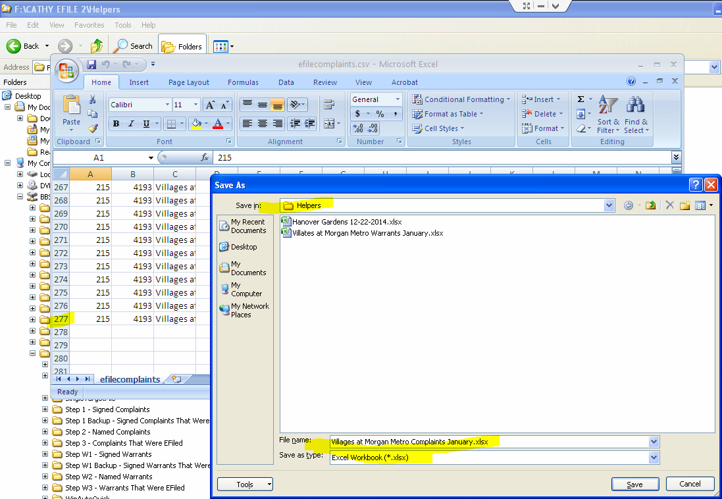

# Step A – Renaming Signed Files

* Go to your Desktop. Use the Windows key at the bottom right of your **Windows Taskbar** at the bottom of your screen to do this (may be hard to see). When you are “on your desktop”, you will see the icons you have put there.

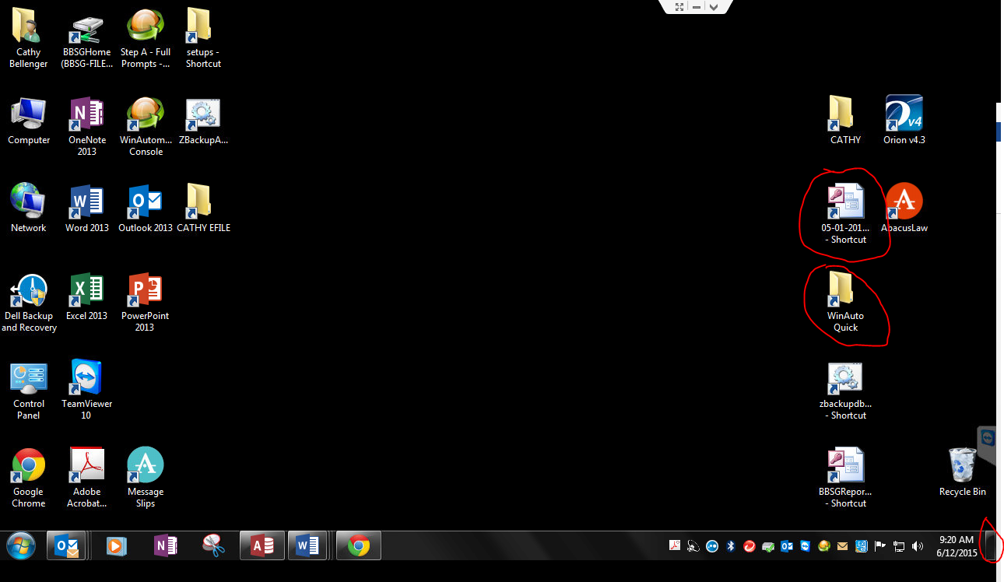

* Right Click on WinAutoQuick
* Select Open.
* Right-click the “Step A” program
* Select Open.

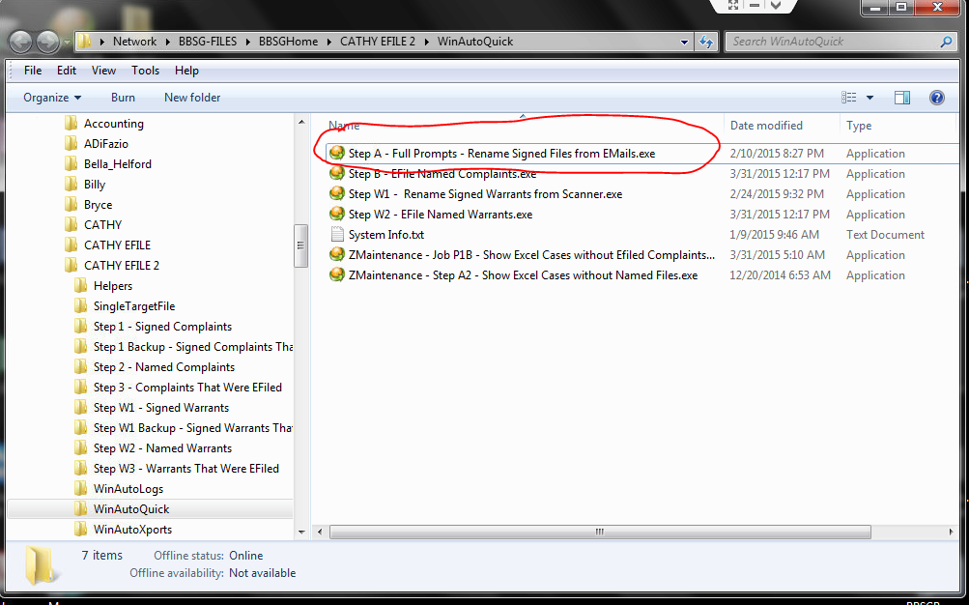

* **Close** the WinAutoQuick Explorer Window that you just opened. Typically you close a window by using the red X at the top right of the window.
* Click OK on the Message Box below.

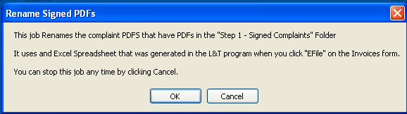

* Enter your name (you must be registered with the system), so that the following file locations are correct. Use “Cathy” on Cathy’s machine.
* Click OK

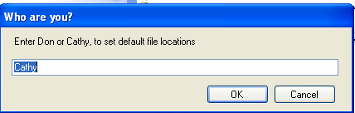

* Click OK to 3 file locations
* Select the Helper Excel File you made in a previous step, e.g. “Villages June 2015 Complaints.xlsx”. (You will automatically already be in the proper folder: F:\CATHY EFILE2\Helpers)
* WAIT (about 10 seconds)

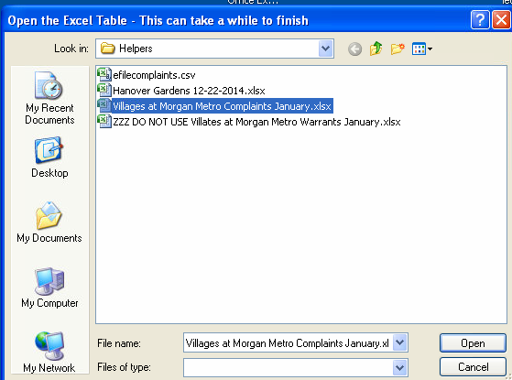

* This Step A routine brings up each case that is in the Excel Helper file.
* For each Complaint
* Type in the “Atty Ref” number from the document. It is on the right side of the Complaint under the Property Title. Warning: the numbers will not show up in order.
* Click OK. If you type the number incorrectly, you will get a notice. If you type the number correctly, you get a Match! Notice.

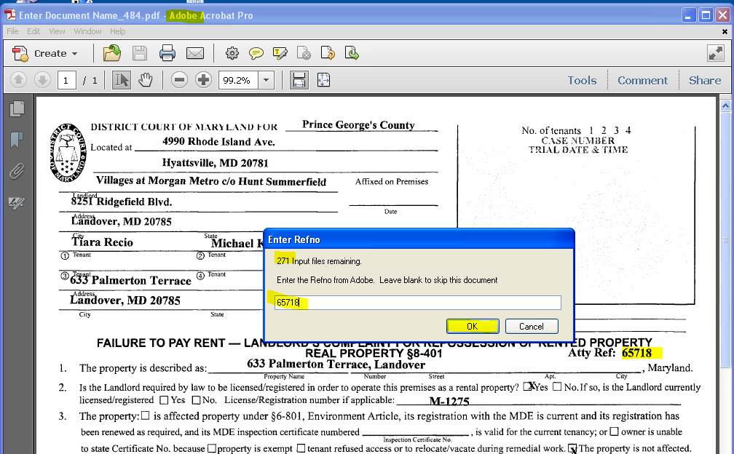

* Verify that the names are the same between the document, and the Match! Message (below), and click Yes.
* If you see a problem, you can click No, and fix things later.
* If things just “hang”,
  + Click “Stop Job” in the small window at the bottom right of your screen.
  + Start again with the steps in this “Step A – Renaming Signed Files” section of this document. You will pick up where you left off.

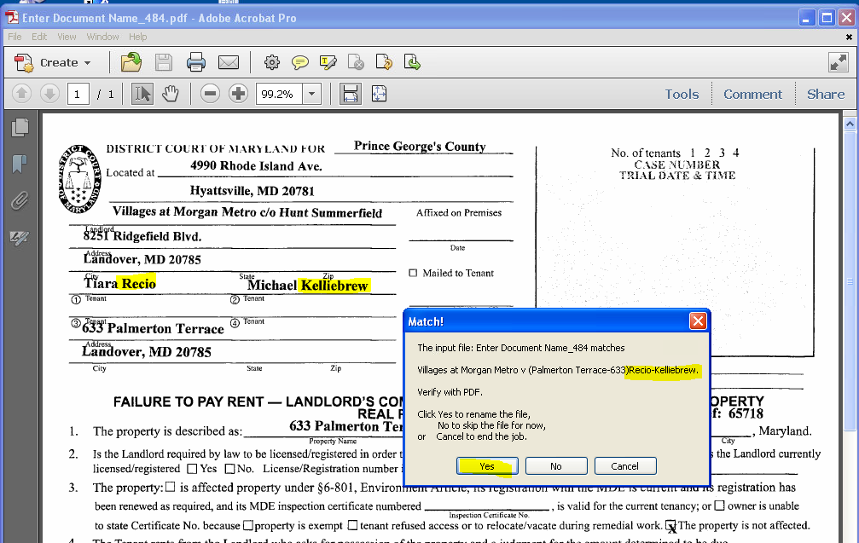

Here is the message you see when one of the signed documents is a duplicate.

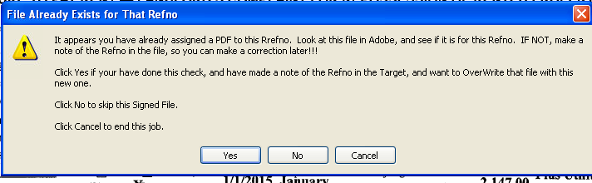

When you have finished renaming the files, you get the completion message.

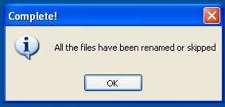

# Connect to EFile Express in the Internet Explorer Web Browser

* If unsure, verify your screen resolution. This will be correct on Cathy’s computer. **This system only runs at 1280 x 720**, because the WinAutomation tool depends on the exact position of various buttons on the web pages.

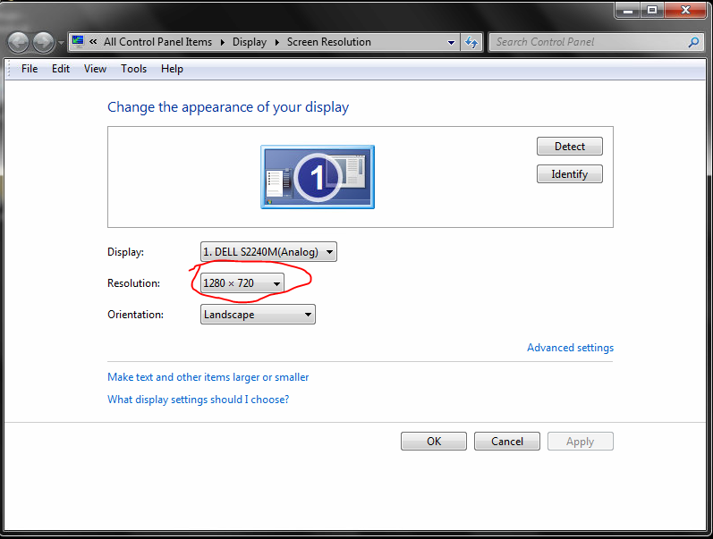

* Start Internet Explorer, which may appear as iexplorer.exe on your Windows Start menu.
* Open the File Express Bookmark (in the Cathy’s folder on her bookmark toolbar), and log in. For reference, the bookmark is <https://secure.fileandservexpress.com/Home/Home.aspx?oldui=true>
* Click on here to log in.

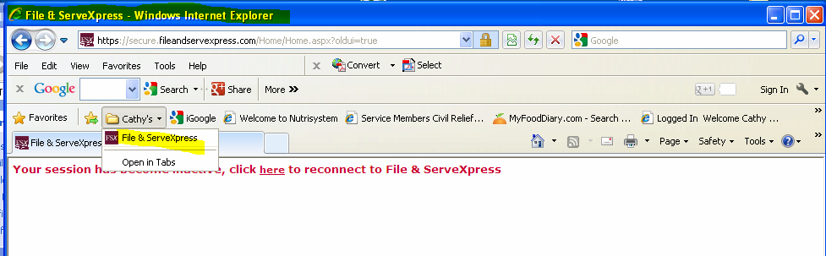

* Click on Filing & Service
* Click on Start A Transaction.
* Make sure this Internet Explorer is Maximized, using button next to the red X on the top right of the window.
* The Internet Explorer window should look exactly as shown below, or else the system may not work. Note there is a tool bar with “Convert” on it, and then the Bookmark Toolbar containing “Cathy’s” below that.

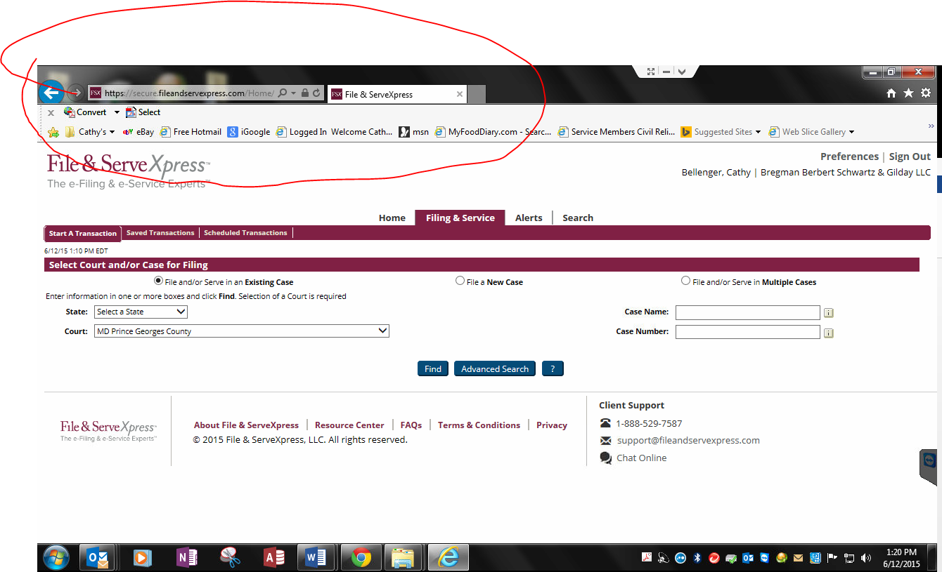

* Leave that window open while you do the next steps.

# Step B – Efile the Named Complaints

* Go to your desktop (see previous instructions about the Windows Desktop button on lower right of your Windows Task Bar).
* Decide what printer you are using, and set it up. If you are using Remote Printing, be sure it is checked in TeamViewer. If you are using a printer locally, be sure it is your “Windows Default Printer”.
* Right-click on the ShortCut to WinAutoQuick
* Select Open
* Right-click on Step B – Efile Named Complaints.exe
* Select Open.

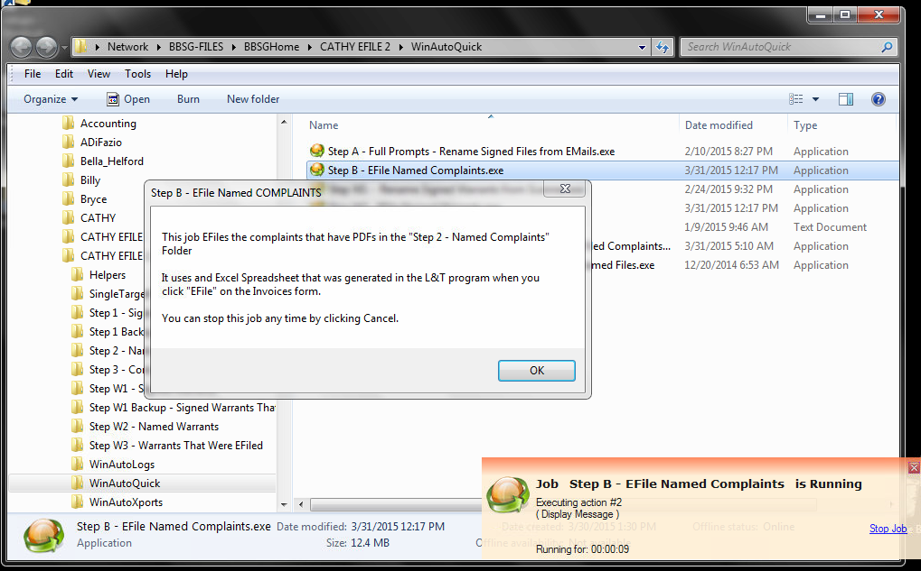

* Note that there is a Small window on the lower right, which contains a link that allows you to stop this “Step B” job at any time. That window will always be there if the job is running.
* Close the larger, WinAutoQuick Window, that shows the various steps (red X on top right of Window)
* Click OK on the button below

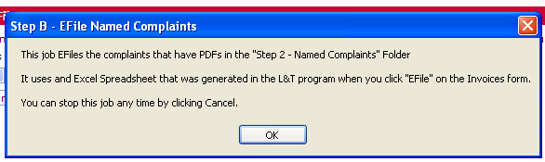

* Enter your name
* Click OK
* Click OK 3 times to accept the next three file locations.
* Select the Excel Helper File you made for Step A. Do this by left-clicking it once. You will see the name repeated in the File Name: text box.
* Click Open.

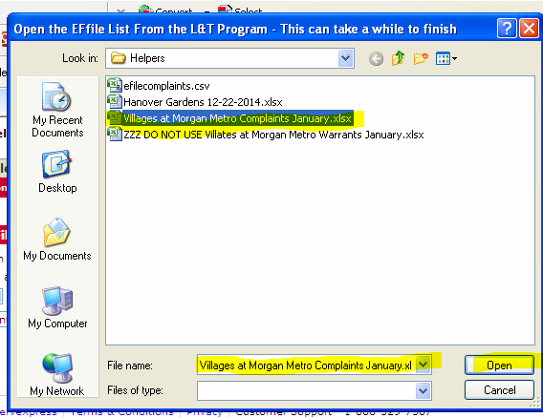

* Edit the date and time for submission. This might typically be at 4 AM or 4:15AM the following day.
* Click OK
* Enter the Plaintiff, properly capitalized. No commas.

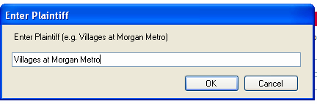

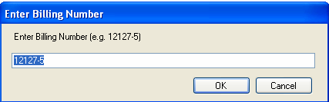x

* Indicate whether you are printing “Remotely” (i.e. at Home). Select this if you are using TeamViewer from home.

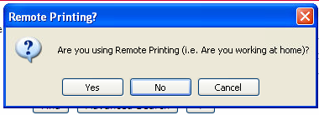

* Select Unattended Processing.
* Minimize (do not Close) the Excel Helper File window.
* Click OK.

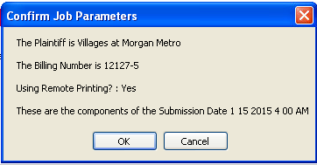

Once you click OK, the Web process starts.

* WAIT (up to 30 seconds)
* Watch Internet Explorer as it processes a Complaint, and continue monitoring as it processes. This procedure is semi-delicate, with many moving parts, and may stop. After each case is filed, a receipt will be printed! The next case will start.
* Monitor the printer for **out of paper**, or **paper jams**.
* **It is very important that you give Cathy the stack of printed receipts from your printer, in order. She uses these to match for case numbers that are returned by the court.**
* Have fun.